1. **Regression**
2. **Activation Functions**

* **Linear (No Activation Functions):**



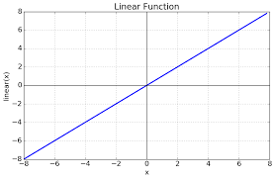

* + **When Used**: Standard regression problems where the output is a real number.
* **Tanh**:

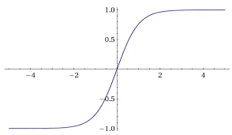

* + **When Used**: Regression problems where the output needs to be scaled between -1 and 1.
* **ReLU**:



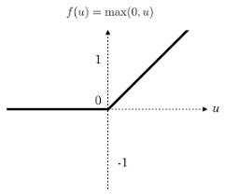

* + **When Used**: Specific cases of regression problems where non-linearity is needed in the output.
* **Leaky ReLU**:



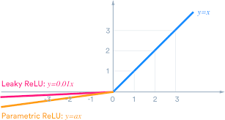

* + **When Used**: To avoid the "dying ReLU" problem in regression tasks.

1. **Cost Functions**

* **Mean Squared Error (MSE)**:



* + **When Used**: Standard regression problems to minimize the squared difference between predicted and actual values.
* **Mean Absolute Error (MAE)**:



* + **When Used**: Regression problems to minimize the absolute difference between predicted and actual values.
* **Huber Loss**:
  + **Equation**:

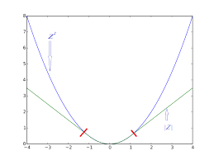

* + **When Used**: Regression problems to be less sensitive to outliers than MSE.

1. **Examples**

* **Predicting house prices**
* **Predicting stock prices**
* **Predicting normalized values that can take both positive and negative values**

1. **Binary Classification**
2. **Activation Functions**

* **Sigmoid**:



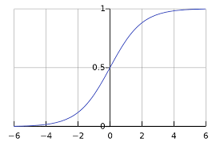

* + **When Used**: Binary classification problems where the output is a probability between 0 and 1.

1. **Cost Functions**

* **Binary Cross-Entropy** (Log Loss):



* + **When Used**: Binary classification problems to measure the performance of a classification model whose output is a probability value.
* **Hinge Loss**:



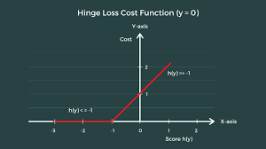

* + **When Used**: Binary classification problems, often used with Support Vector Machines (SVMs).

1. **Examples**

* **Predicting whether an email is spam or not**
* **Predicting whether a customer will buy a product (yes/no)**

1. **Multi-Class Classification**
2. **Activation Functions**

* **SoftMax**:



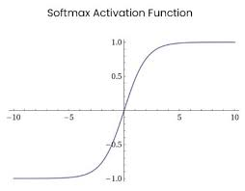

* + **When Used**: Multi-class classification problems where the output is a probability distribution over multiple class.

1. **Cost Functions**

* **Categorical Cross-Entropy**:



* + **When Used**: Multi-class classification problems to measure the performance of a classification model whose output is a probability value over multiple classes.
* **Sparse Categorical Cross-Entropy**:



* + **When Used**: Multi-class classification problems when labels are integers rather than one-hot encoded vectors.

1. **Examples**

* **Classifying images of handwritten digits into one of 10 classes (0-9)**
* **Classifying types of animals in an image dataset (e.g., cat, dog, horse)**

1. **Summary**
2. **Regression**:
   * **Activation Functions**: Linear, Tanh, ReLU, Leaky ReLU

* + **Cost Functions**: Mean Squared Error (MSE), Mean Absolute Error (MAE), Huber Loss

1. **Binary Classification**:
   * **Activation Function**: Sigmoid



* + **Cost Functions**: Binary Cross-Entropy, Hinge Loss

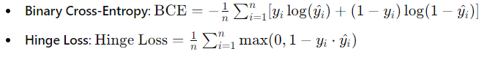

1. **Multi-Class Classification**:
   * **Activation Function**: Softmax



* + **Cost Functions**: Categorical Cross-Entropy, Sparse Categorical Cross-Entropy

